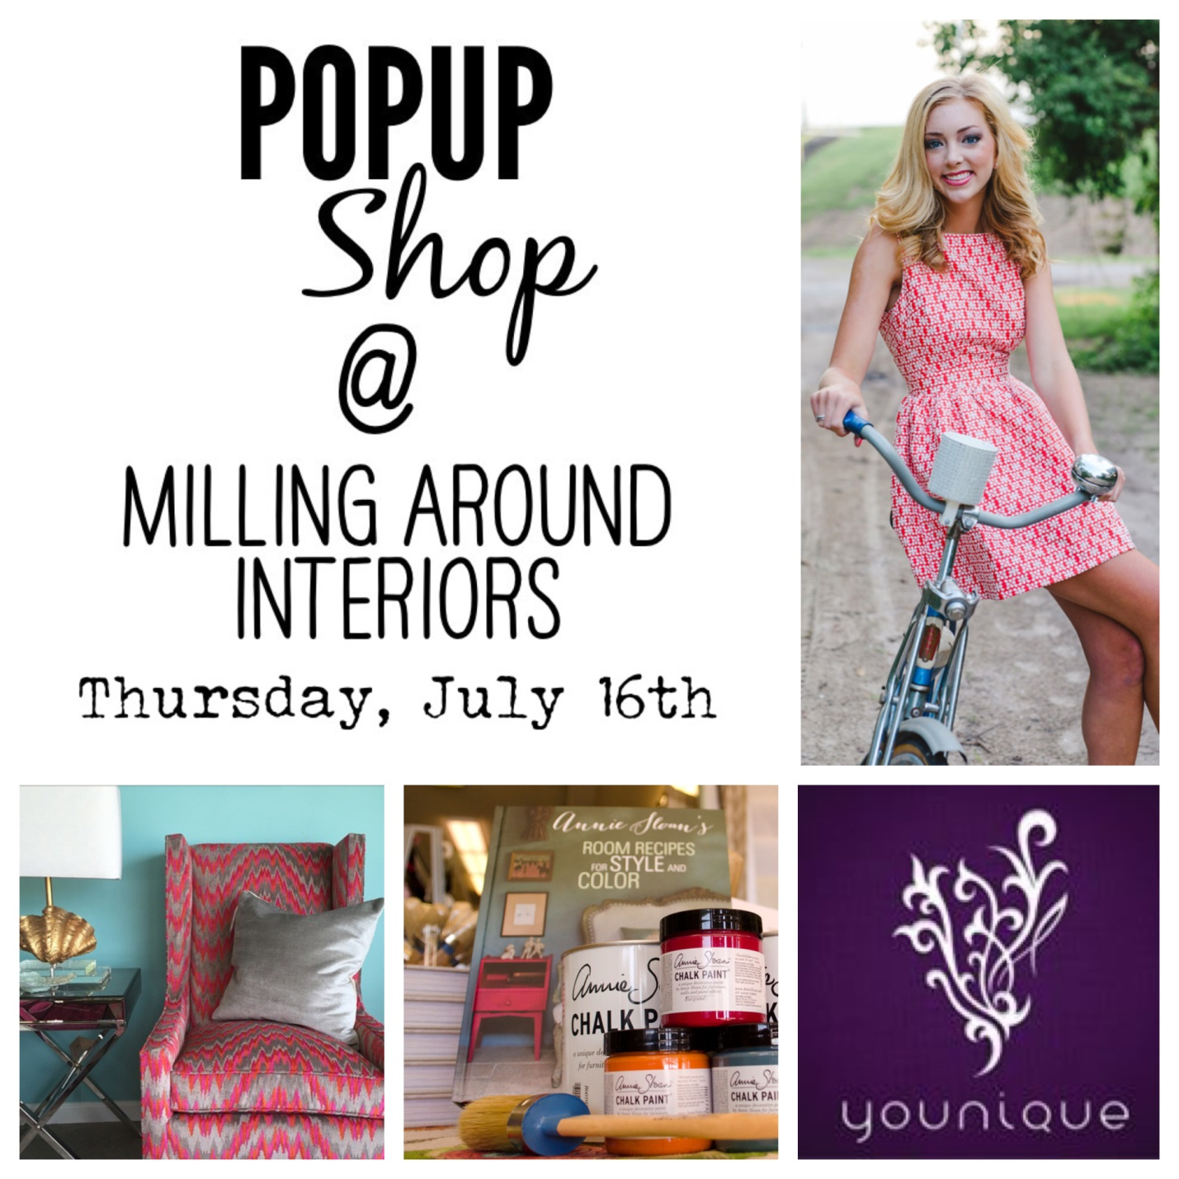
Wanderlust by Abby + Milling Around Interiors are joining creative forces for one night ! Showcasing new summer styles, from clothes and accessories to textiles and mascara ! We will have it all at this summer pop up shop!
Come Unwind After Work! There Will Be Wine, Hors d’oeuvres, & Summer-Wear!

